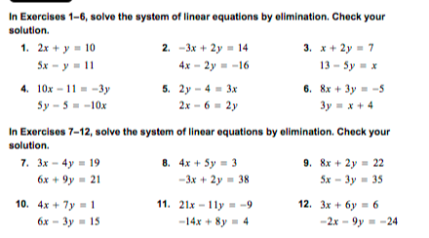
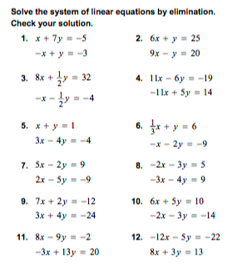
Algebra OPFI Name: ___________________________

U5 LT3 Part 2 Elimination
Additional Problems.

LT 3: Students will be able to find the solution of a system of linear equations algebraically.

