Algebra OPFI Name: _____________________________

U5 LT 1/2 Quiz Review

LT 1: Students will be able to determine whether an ordered pair is a solutions to a system of linear equations.
LT 2: Students will be able to find the solution of a system of linear equations by graphing the equations using technology and analyzing the relationship between the graphs of each function.
Success Criteria #1
Determine if the ordered pair is a solution of the system of linear equations
Ex 1: (1,4); y = 2x + 2 Ex 2: (5,3); x + 3y = 14
3x – 2y = -5 y = x – 2

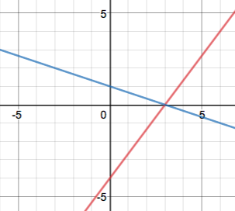

Ex 3: What is the solution of the system of equations graphed to the right?

Ex 4: Use your graphing calculator to sketch the following and then solve the system of equations.
Success Criteria #2

Determine if the ordered pair is a solution of the system of linear equations.
1. (2,5); x + y = 7 2. (-2,0); y = -2x – 4
2x – 3y = -11 y = x + 4

Solution? Yes or No Solution? Yes or No

Use your graphing calculator to sketch the following and then solve the system of equations.

3. $y=\frac{2}{3}x-2$ 4. y = -x + 6
y = $-\frac{4}{3}x+4$ $y=\frac{1}{2}x+9$

Solution: ______________ Solution: ______________

Sketch a system of linear equations that has NO SOLUTION.

