Algebra OPFI Name: _____________________________

**U5 LT1 Is it a Solution?**

*U5 LT 1: Students will be able to determine whether an ordered pair is a solutions to a system of linear equations.*

*Success Criteria:*

**U5 Vocab**

System of Linear Equations:

Solution of a System of Linear Equations

An ordered pair is a solution to a system of equations if it is a solution to _____________ equations.

|  |  |
| --- | --- |
| Equation 1 | Equation 2 |
|  |  |
| Does it work? | Does it work? |
| Is the ordered pair a solution to the system of linear equations? | |

|  |  |
| --- | --- |
| Equation 1 | Equation 2 |
|  |  |
| Does it work? | Does it work? |
| Is the ordered pair a solution to the system of linear equations? | |

**Example 1: Checking Solutions**

Is the ordered pair is a solution of the **system of linear equations**?

**a. (2,5); x + y = 7 b. (-2,0); y = -2x – 4**

**2x – 3y = -11 y = x + 4**

*Success Criteria:*

|  |  |
| --- | --- |
| Equation 1 | Equation 2 |
|  |  |
| Does it work? | Does it work? |
| Is the ordered pair a solution to the system of linear equations? | |

|  |  |
| --- | --- |
| Equation 1 | Equation 2 |
|  |  |
| Does it work? | Does it work? |
| Is the ordered pair a solution to the system of linear equations? | |

**You Try…**

Is the ordered pair is a solution of the system of linear equations?

**a. (1,-2); 2x + y = 70 b. (1,4); y = 3x + 1**

**-x + 2y = 5 y = -x + 5**

**U5 LT2 Finding Solutions by Graphing**

The solution of a system of linear equations is the point of ____________________ of the graphs of the equations.

**Example 1: Solving Systems of Linear Equations.**

Find the solution to the following system of linear equations.

1. 2. You Try....



**Example 2: Solving Systems of Linear Equations using your graphing calculator.**

*Use your graphing calculator to sketch the following and then solve the system of equations. (Use orange graphing directions)*

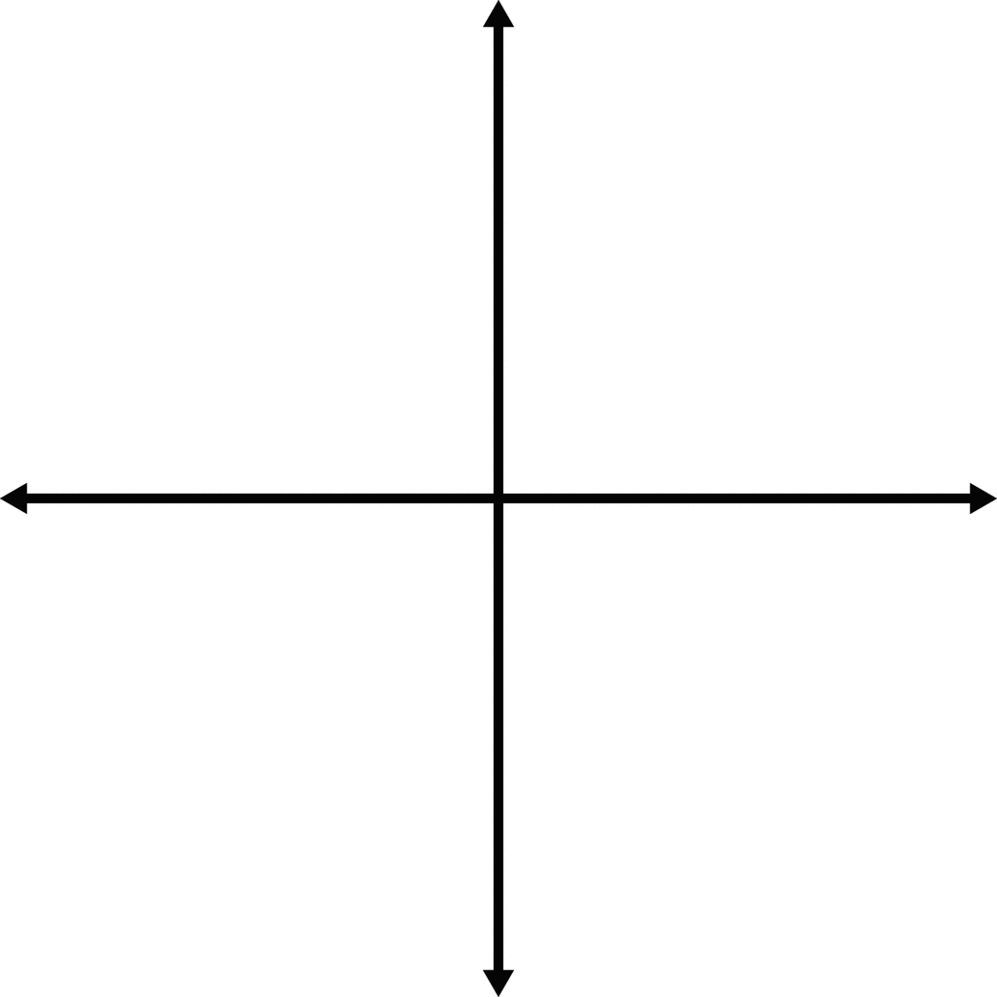1. $y=\frac{2}{3}x-2$ 2. y = x – 8

y = $-\frac{4}{3}x+4$ y = x + 1

Solution: ______________ Solution: ______________

Check: Check:

You Try…

*Use your graphing calculator to sketch the following and then solve the system of equations.*

1. 2. y = -x + 6

y =

Solution: ______________ Solution: ______________

U5 LT1 Practice

*Use your graphing calculator to sketch the following and then solve the system of equations.*

4. y = x – 8 5. y = x – 4 6. $y=\frac{2}{3}x-1$

y = -2x + 1 y = -2x + 17 y = -x + 4

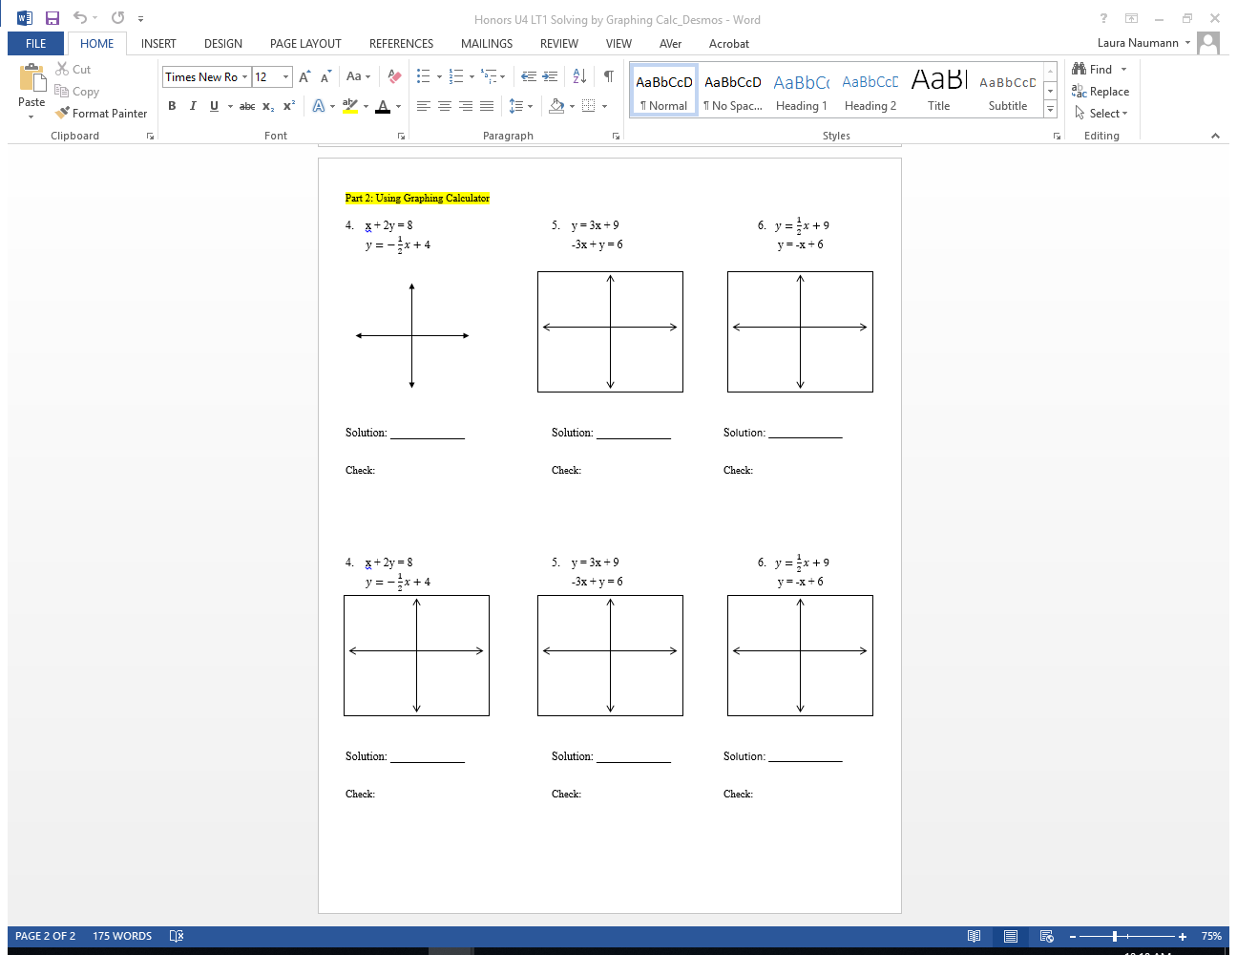

Solution: _____________ Solution: _____________ Solution: _____________

7. 8. y = -x + 7 9.

y = -3x + 14 $y=-\frac{2}{3}x+12$ y = x – 7



Solution: _____________ Solution: _____________ Solution: _____________

10. y = 3x – 10 11. y = 3x + 9 12. $y=\frac{1}{2}x+9$

$y=-\frac{1}{2}x+4$ y = -3x + 6 y = -x + 6



Solution: _____________ Solution: _____________ Solution: _____________

13. y = 3x – 1 14. $y=-\frac{1}{2}x+3$ 15. $y=6x+1$

$y=-x-5$ y = 2 y = 6x – 2





Solution: _____________ Solution: _____________ Solution: _____________