Algebra OPFI Name: ______________________________

**U5 LT1/2 Group Review**

*LT 2: Students will be able to find the solution of a system of linear equations by graphing the equations using technology and analyzing the relationship between the graphs of each function*

*Success Criteria:*

*LT 1: Students will be able to determine whether an ordered pair is a solutions to a system of linear equations.*

*Success Criteria:*

*.***LT 1:**

*Determine if the ordered pair is a solution of the* ***system of linear equations****.*

Is the ordered pair is a solution of the **system of linear equations**?

1.   2.  3. 

4.  5.  6. 

7.  8. 

**LT 2:**

Solve the following system of equations by graphing.

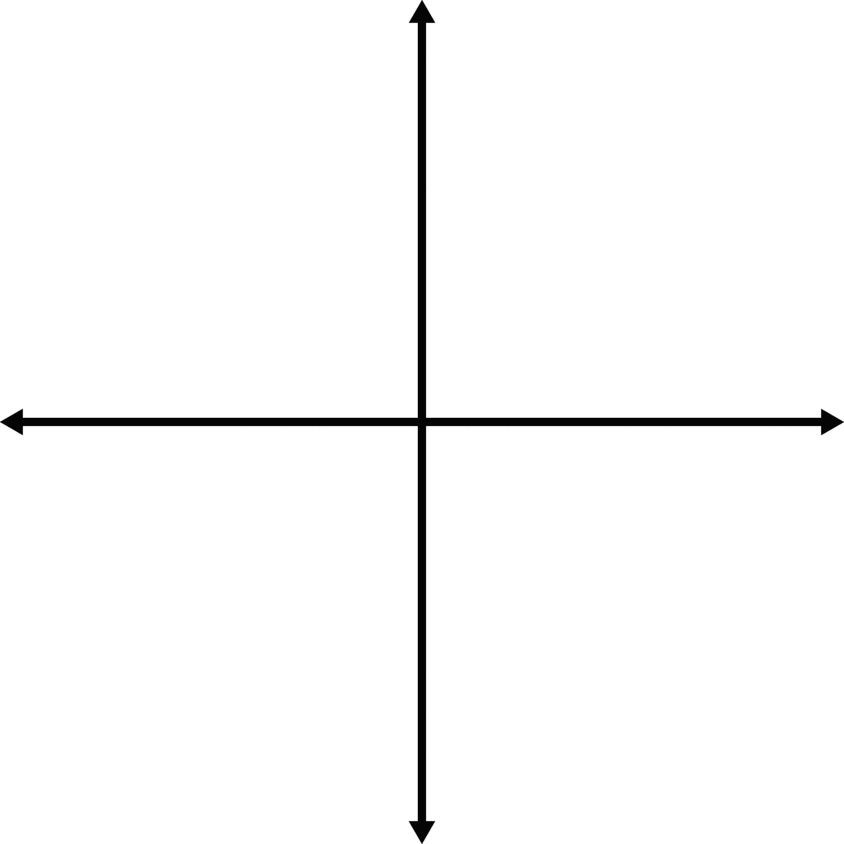1. $y=\frac{1}{2}x-5$ 2. y = x + 8

y = $x-8$ $y=-\frac{3}{4}x+1$

Solution: ______________ Solution: ______________



3. 4. y = -x – 3

y =

Solution: ______________ Solution: ______________



5. 6. y = -x + 4

y =

Solution: ______________ Solution: ______________