Algebra OPFI Name: _____________________________
U4 LT6 Graphing Slope Intercept Form
LT 6: SWBAT graph a linear function.

Slope (m) =

y-intercept (b) =

Success Criteria:

Slope Intercept Form
y = mx + b

Ex 1. Find the slope and y–intercept of You Try.... Find the slope and y–intercept of
y = 2x + 3 $y=-\frac{1}{2}x-2$
Slope: Slope:
Inc or Dec? Inc or Dec?
y-intercept: y-intercept:

Graphing using the slope/y-intercept
Ex 2: Graph the following.
$$y=\frac{1}{3}x+3$$

Slope:

Inc or Dec:

y –intercept:

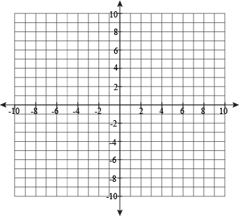
Steps to graph using Slope Intercept Form
1.)

2.)

3.)

Ex 5: Graph the following.
$$y=-x-4$$
Slope:

Inc or Dec:

y –intercept:

Ex 4: Graph the following.
$$y=-4x+2$$
Slope:

Inc or Dec:

y –intercept:
Ex 3: Graph the following.
$$y=2x-7$$
Slope:

Inc or Dec:

y –intercept:

You Try: Graph the following.
$$y=x+1$$
Slope:

Inc or Dec:

y –intercept:

You Try: Graph the following.
$$y=-\frac{1}{2}x+3$$
Slope:

Inc or Dec:

y –intercept:

You Try: Graph the following.
$$y=2x$$
Slope:

Inc or Dec:

y –intercept:

Practice
1.) y = -x + 2 2.) $y=3x+4$

3.) y = -2x - 3 4.) $y=-\frac{3}{4}x+3$

5.) y = x - 3 6.) $y=\frac{3}{2}x+6$

7.) y = -3x + 6 8.) $y=\frac{4}{5}x$

9.) y = x 10.) $y=-\frac{2}{3}x+3$

11.) y = x + 2 12.) $y=-\frac{1}{3}x+2$

